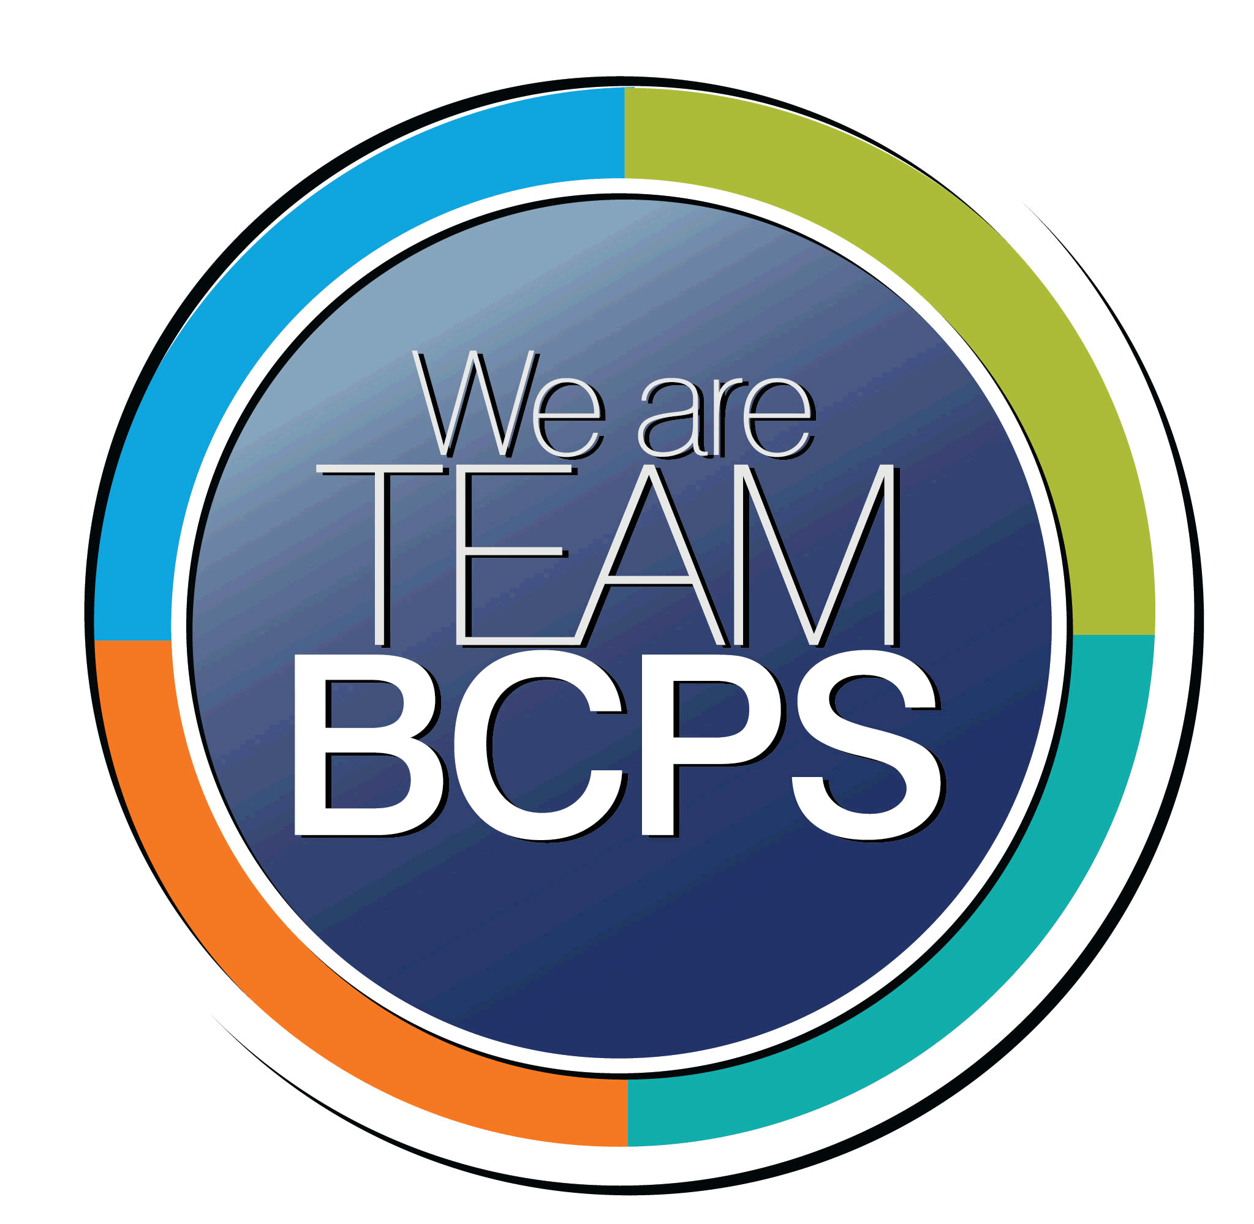 **Schoolwide Positive Behavior Plan** 

**Baltimore County Public Schools**

**Date Completed: 11/29/2021 School Year 2022-2023**

**School: Westchester Elementary School**

|  |
| --- |
| **Section 1: Initial Steps** |
|  |
| **School Climate Team** |
| *Identify members of a School Climate Team (consider a representative selection of members). The team meets initially to examine equity concerns and data and to develop the Schoolwide Positive Behavior Plan. The team should then meet monthly (minimum quarterly) to assess the effectiveness of the SWPBP on an ongoing basis.* |
| Phil Byers, Jenna Mcrae, Beth Allen, Kelsey Maguire, Nicole Findley, Samantha Hopkins, Colleen Uzupus, Victoria Bertovich, Adele Delibera, Kerri Keenan, Amanda Kind, Joanne Milani, Vicki Charikofsky, Julie Mangano, Hannah Owen, Shasta Noriega, Stacey Lattea, Aaron Mitton, Michelle Redmiles, Rebecca Moorman, Lynsay Maltese |
| **Equity Lens** |
| *Through an equity lens, identify what the data indicate about the social-emotional needs of students and the support provided by staff members relative to disproportionality between student groups, especially for African Americans or students receiving special education. Also consider the school’s population with regard to ELL, Latinx, and/or other student groups. (Information may be from School Data Story)* |
| Continue to expand on our Restorative Practices beyond the classroom, to include Buses and outside the classroom setting (cafeteria, playground) in order to build understanding of acceptable school wide behaviors and character education that supports our culturally diverse population.  Continue to build relationships through mentoring and conflict resolution so that our Black and Hispanic students feel a greater sense of belonging to the school community |
| **Data Analysis** |
| *Summarize what the data tell about the school climate. (Information from School Data Story)* |
| 2021 BCPS stakeholder Survey:  In general, students responded positively to questions regarding feeling respected and sense of belonging.  “*Adults at my school care about me*” 97% agree  “*Adults at my school treat me with respect*” 97% agree  “*Students at my school treat me with respect*” 91% agree  “*I feel welcome at my school*” 96% agree  “*I feel safe at my school*” 97% agree  “*I was bullied at this school*” – 77% responded NO 23% responded YES with most incidents occurring on the Bus or outside of the Classroom.  The two lowest scoring areas were:  “*Most students stop and think before acting when angry*” 65% agree  “*I feel like I can be myself when I am at school*” 78% agree |
| **Climate Goals** |
| *Identify the school’s goals in improving the social-emotional climate of the building. (Information from School Progress Plan)* |
| Implementation of daily classroom community circles and monthly counseling lessons with continuing focus on bullying/peer conflict and Restorative Practices.  Implementation of Mentoring programs (Boys to Men) that enhances engagement and builds a greater sense of connectedness and trust among identified underserved student populations.  Engage in staff conversation when marginalized or special needs students are not being afforded access and opportunity with grade level expectations.  Implementation of staff discussions around the progress of individual students in underserved populations with a focus on the shifts or changes being made to meet the needs of each student. |
| **Section 2: Developing and Teaching Expectations** |
|  |
| **Expectations Defined** |
| *Identify a School Code of Conduct with 3-5 positively stated school expectations. Develop a way to communicate the identified rules, based on the schoolwide expectations, for specific settings within the school building. Expectations should be clearly stated, communicated, taught, and frequently referenced.* |
| Westchester Stars “Soar to Success”  Today, I promise to soar to new heights.  I will be: SAFE ORGANIZED ACCOUNTABLE RESPECTFUL |
| **Classroom Plan for Teaching and Reinforcing Expectations, Routines, and Procedures** |
| *Teachers develop visuals to communicate culturally relevant classroom expectations, routines, and procedures based upon the schoolwide expectations. Educators explicitly teach expectations, routines, and procedures. The school staff recognize and reinforce expected and positive behavior. Teachers identify encouraging procedures and corrective procedures for their classrooms.* |
| Westchester follows the Restorative Approach to discipline. We believe that instead of punishment, students should have a chance to learn from their mistakes and repair damaged relationships. We agree that classroom management is defined as being “about building relationships with students and teaching social skills along with academic skills.”  School Discipline procedures fall under the purview of the WES Climate Action Committee. The following outlines Westchester’s School Discipline Procedure which is a combination of Virtue Language, Conscious Discipline, and Restorative Practice.  **Virtual Language**: School-wide language that facilitates conversations about behaviors including the following:  To Acknowledge and Thank example-It was kind of you to help us out.  To Guide example-Please be considerate of others.  To Correct example-What is a respectful way to say that?  **Conscious Discipline**: Foundational environment / The school family increases connections between adults and children at all levels, ensuring optimal development and learning for all. A school family culture is built through consistent modeling of routines, rituals and structures.  **Restorative Practice**: Creating a community (in each classroom, grade, and school) that works to repair harm and restore relationships.  1. “PLAN B” creating an easily accessible activity for all students that requires no teacher direction. An example would be First in Math.  2. “PROBLEM-SUBBING” (administrator initiated) An event has taken place that needs to be addressed outside the classroom setting. An administrator would obtain an available staff member to come implement “Plan B” while the teacher steps out to repair and restore relationships utilizing restorative questioning. During this time, administrator, teacher, and student could contact the parent together.  3. “LOGICAL CONSEQUENCES” Interventions by an adult that create a helpful learning experience to encourage children to make better choices and maintain respect of child, include relevant consequence, and have a realistic timeframe. Example- child throws lunch in Café. Punishment would be loss of recess, Logical Consequence instead of punishment would be that student takes responsibility for actions and repairs relationship with Custodian in Café and helps to clean up the mess. |
| **Family/Community Engagement** |
| *Identify how the Schoolwide Positive Behavior Plan, the schoolwide expectations, and/or interventions will be communicated and shared with families. Consider how to include family and student voice in the initial plan and in evaluating the plan throughout the year.* |
| Westchester’s Schoolwide Behavior Plan and student behavior expectations will be communicated and shared with our stakeholders in the following ways: 1. Teacher -led discussions during Fall Back to School Night Parent Meetings 2. Inclusion in the August/September School Newsletter sent home to all stakeholders. 3. Shared at the September General PTA Meeting with opportunity for parent comment and input provided. 4. Use of student response from Spring Stakeholder Survey to develop continuing Focus of Plan to reflect needs of the school house.  5. Posted on the Westchester Elementary Website in the Fall of each year. |
| **Section 3: Developing Interventions and Supporting Students** |
|  |
| **Resource Mapping of MTSS** |
| *Identify the evidence-based practices and interventions offered at Tier 1, Tier 2, and Tier 3 to support all students. Consider what culturally responsive interventions the school requires to meet the specific needs of the students.* |
| **Level 1 Behaviors**: Inappropriate Language, Physical Contact(pushing,shoving), Defiance, Disrespect, insubordination, non-compliance, Lying,cheating, Drawing/Writing inappropriate things, Teasing,Taunting, Distruption  **Level 1 Behavior Responses**: These behaviors are handled by the classroom teacher or staff member witnessing such behaviors and possible responses/intervention can include the following: 1. Use of buddy/classroom 2. Alternative recess 3. Phone call home 4. Restorative Questions 5. Zones of Regulation  Behaviors and contact with Home should be documented in teacher records for future reference.  **Level 2 Behaviors**: Abusive Language(threat of physical harm/racial/sexual comments), Harassment, Fighting where a student is injured, Theft or property damage, Constant disruption of the class, Ongoing Level 1 behaviors that are not responding to interventions  **Level 2 Behavior Responses**: These behaviors are handled by the classroom teacher/staff member witnessing such behaviors and administration. Behaviors are so extreme or disruptive that the teacher needed to implement “Plan B” but prior possible responses/interventions include: 1. Use of Buddy Classroom, 2. Alternate recess 3. Phone call Home 4. Restorative Questions 5. Zones of Regulation  If behaviors persist and/or escalate after implementation of at least 2 interventions, administration should be contacted and a referral completed.  Behaviors and contact home should be documented in teacher records for future reference.  The behaviors should be shared with the parent by the teacher and administrator  Depending on data collected and discussed with administration and counselors, a referral for SST might be appropriate.  **Level 3 Behaviors**: Arson, Bomb Threat, Use/Possession of Alcohol, Use/Possession of drugs, Use/Possession of Tobacco, Use/Possession of Deadly Weapon  **Level 3 Behavior Response**: 1. Complete Office Referral immediately and call for an Administrator |
| **Social-Emotional Learning** |
| *Identify the specific evidence-based social-emotional learning skill development practices the school will implement during the school year. Consider the importance of trauma-informed care, mental health awareness, level of students’ coping skills, etc. Determine how the social-emotional learning and the SEL competencies will be integrated into the school’s programming. Consider the need for any training the staff members may require.* |
| School Counselors will provide monthly counseling lessons to each K-5 classroom regarding topics such as Bullying, Personal Safety, Relationship Skills, Celebrating Differences, Character, Mindfulness, and Coping Skills  The Month of May focuses on mental health awareness and provides activities and resources to raise awareness of the importance of mental health in conjunction with self cre and positive coping mechanisms.  Our SEL competencies are incorporated in monthly counseling lessons as well as individual counseling and group counseling. The school counseling department provides training for topics such as: anxiety, grief, trauma-focused care, depression, and the LGBTQ community.  The SEL Resource Teacher provides regularly scheduled social skills services to our children who receive SCLS and IEP services. |
| **Character Education** |
| *Determine how specific evidence-based character education learning will be infused into the school’s programming to promote positive behavior and ethical decision-making. Character education will be culturally responsive and co-created with diverse stakeholders. Consider the need for any training the staff members may require.* |
| The month of January focuses specifically on character education. Each K-5 classroom will receive a character lesson focusing on whole body listening, self control, communication skills, embracing our differences, perseverance and cyber safety.  The school counseling department provides training on how to facilitate these monthly lessons in a culturally sensitive and appropriate manner. |
| **Professional Development for Staff** |
| *Identify the professional development that will be offered to staff members throughout the year in order to support their knowledge, skill development, and implementation of the interventions selected, the character education learning, and social-emotional learning practices. Specify the schedule for professional development and how to obtain teacher feedback during the year to address their concerns and areas in which they want/need more information. (Information from School Progress Plan.)* |
| **August/September**: Provide schoolwide professional development to review and enhance current practices with a focus on Recess/Bus/Cafeteria behaviors. Provide schoolwide professional development to unpack key actions and the rationale/data for selecting them.  **Ongoing through the Year**: Classroom Daily Community Circle Meetings structured with a focus on consistently reviewing school expectations. Monthly Counselor led Class Meetings focused on identified Monthly Virtues in the context of school wide appropriate behaviors during time outside of classroom. Quarterly Climate Action Committee meetings to review school wide Behavior Plans and school wide date to adjust SEL Program Development of Mentoring programs that support the specific needs of target populations ( Boys to Men Club) in effort to provide opportunities to promote greater sense of belonging and positive self image.. |
| **Section 4: Supporting and Responding to Student Behavior** |
|  |
| **Recognitions/Incentives** |
| *Identify a variety of positive consequences, acknowledgements, recognitions, and/or incentives that are linked to the behavioral expectations and rules. Develop a system for implementing the positive acknowledgements consistently in school settings. Consider how to monitor who is being recognized and who is not being recognized and whether explicit or implicit biases may be occurring.* |
| Class DOJO – earn prizes once student gets to 25 pts. DOJO Dollars can be used to shop at DOJO Store.  Class Compliment Jar – Fill to earn class reward  Student Shining Stars – 2 students recognized each day for outstanding contributions  Punch Cards – When card is full, student picks from a prize bin  Happy Notes Home/Student Spotlight – tracking so all students receive a note  Rewards: Lunch Bunch, Extra recess, Prize Bin, Notes Home, PJ Day, DOJO Store, Class Game, Students determine rewards when possible. |
| **Hierarchy for Behavioral Referrals and Consequences** |
| *Identify the behaviors that are teacher-managed, behaviors referred to resource staff, and behaviors referred to administration. Refer to the BCPS Student Handbook for teacher and administrator-led interventions. Consider how unsafe behaviors will be addressed.* |
| **Teacher Managed Behaviors**: Inappropriate Language, Physical Contact (pushing, shoving), Defiance, Disrespect, Insubordination, Non-Compliance, Drawing/Writing inappropriate Things, Lying or Cheating, Teasing or Taunting, Disruption  **Teacher and Administrator Managed Behaviors**: Abusive Language (Threat of physical harm/racial/sexual comments), Harassment, Fighting where a student is injured, Theft or Property Damage, Constant Disruption of the Class, Ongoing Level 1 behaviors that are not responding to Interventions.  **Administration Managed Behaviors:** Arson, Bomb Threat, Use/Possession of Alcohol, Use/Possession of Drugs, Use /Possession of Tobacco, Use/Possession of Deadly Weapon.  **Resource Staff Referral for Behaviors**: Any behaviors that are considered by the teacher to be representative of a deeper seated social or emotional concern in need of additional support (counseling, Student Support Team Meeting, Mentoring opportunity….) |
| **Response for Intensive Behaviors** |
| *Identify a hierarchy of responses to intensive behaviors (i.e., emergency/crisis management/threat assessment/unsafe behaviors) including interventions and supports. Indicate which school staff members will respond as well as procedures and training as needed.* |
| Crisis Management Team: The staff members trained in CPI-nonviolent crisis intervention include; Administration Team/ *P. Byers* and *J. McRae*, Staff Members currently Trained/ *B*. *Allen* and *K. Maguire*, Staff members to be trained in future/*G. Santos* and *J. Craig.*  If Student behavior is too intense for either the use of a Buddy Classroom timeout or a “Plan B” call for restorative teacher/student conversation outside the classroom, then an immediate removal of student to the Safe Room located in the Social Emotional Resource teacher’s Office will occur. Student will then work with Counselor or Social Emotional Teacher to calm down enough for a phone call to a parent to assist with the de-escalation process. When possible a parent in person meeting is preferred.  Once the situation has returned to normal, team will follow Level 2 Behaviors Interventions to work toward getting the student back to class. |
| **Monitoring the Schoolwide Positive Behavior Plan/Data Analysis** |
| *Identify the data that will be collected and reviewed by the School Climate Team in order to identify behavior trends, patterns, action steps, and interventions using a problem-solving strategy. Consider having a uniform referral form for staff to complete to document referrals to administration. Consider how teachers should document classroom-managed concerns/behaviors/difficulties. (Information from School Progress Plan.)* |
| Stakeholder’s Survey Results Office and Bus Referrals  Counseling Summary Reports (Referrals by Grade, Students receiving regular counseling, Schoolwide Behavior Concerns)  Bullying Reports Quarterly Climate Action Committee Summary Reports |
| **Section 5: Miscellaneous Content/Components** |
| NA |